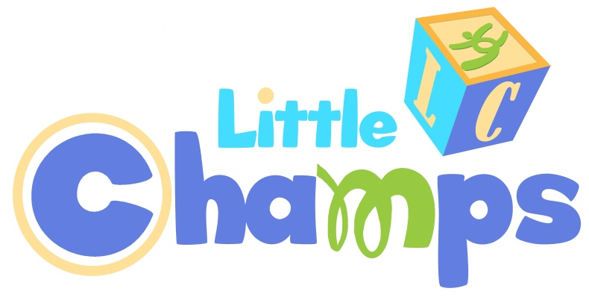
club champion gymnastics

Back to Gym Open House!
Sunday, July 29
10 am, 10:30 am, 11 am, & 11:30am

Club Champion Pasadena is offering FREE 30 minute
Open Gym sessions in our Little Champs Gym!
For ages 12 months-4 years.
Come learn all about our new Parent and Me 1 and Parent and Me 2 programs!

Spaces are limited, so please sign up
using the form below or online at go2clubchampion.com
All current gym members who bring friends will receive a $10 gift certificate to Chalk It Up!
145 Vista Ave. Suite 110 Pasadena 91107 626.577.4496 go2clubchampion.com

Open Gym Time: 10:00am____ 10:30am____ 11:00am____11:30am____

Child’s Name:_______________________ Birthdate:___________ Parent Email:____________________________

Spaces are limited. If the time slot you’ve requested is not available, we’ll contact you with an alternate time.

I’m Bringing Friends!

Child’s Name:_______________________ Birthdate:___________ Parent Email:____________________________

Child’s Name:_______________________ Birthdate:___________ Parent Email:____________________________

Child’s Name:_______________________ Birthdate:___________ Parent Email:____________________________

All brand new participants must complete a gym waiver prior to going onto the gym floor.

